**NAME OF SCHOOL: ................................................................................**

**NAME OF CANDIDATE: ..........................................................................**

**INDEX NO: ..................................... SIGNATURE: ................................**

**553/1**

**BIOLOGY**

**PAPER 1**

**JUNE/JULY**

**2½ HOURS**



**ELITE EXAMINATION BUREAU MOCK 2019**

**Uganda Certificate of Education**

**BIOLOGY**

(Theory)

**PAPER 1**

2 HOURS 30 MINUTES

**INSTRUCTIONS TO CANDIDATES:**

* *This paper consists of three sections* ***A, B*** *and* ***C****.*
* *Answer* ***all*** *questions in section* ***A*** *and* ***B*** *plus* ***two*** *questions in section* ***C.***
* *Write the answers to section* ***A*** *in the boxes provided, answers to section* ***B*** *in the spaces provided and answers to section* ***C*** *on answer sheets provided.*
* *Any additional question(s) answered will not be marked.*

**SECTION A:**

1. Which parental pair could produce a colour blind female?

A. homozygous normal vision mother and colour blind father.

B. colour blind mother and normal vision father.

C. heterozygous normal vision mother and normal vision father.

D. heterozygous normal vision mother and colour blind father.

2. The main constituents of a bone are calcium and;

A. phosphate B. potassium

C. carbonate D. sulphate

3. Which of the following trace elements is added to tooth paste for maintenance of healthy teeth?

A. zinc B. fluoride

C. copper D. manganese

4. Which of the following is the best description of respiration?

A. Breathing in oxygen and breathing out carbon dioxide.

B. absorption of oxygen in the alveoli.

C. release of energy in the cell.

D. gaseous exchange.

5. Which of the following is the definition of a community?

A. place where an organism lives

B. number of species interacting in a locality.

C. influence of one organism on the other.

D. nutritional interrelation of organisms.

6. The most important sign of maturity in females is:

A. development of breasts B. growth of pubic hair

C. the process of ovulation D. softening of the voice

7. Which one of the following shows the correct path followed by the sperms when ejaculated?

A. seminiferous tubules, epididymis, sperm ducts, urethra

B. epididymis, seminiferous tubules, urethra, sperm ducts

C. sperm ducts, seminiferous tubules, epididymis, urethra

D. seminiferous tubules, urethra, sperm ducts, epididymis

8. If a normal heterozygous man marries an albino woman, what will be the genotype of the off springs?

A. **Aa** and **aa** B. **Aa** only

C. **AA** and **aa** D. **Aa** and **AA**

9. Metamorphosis is a stage when;

A. there are larvae formed in a life cycle

B gradual changes occur in organisms developed

C. there is rapid change from adult to juvenile form

D. the body becomes segmented

10. Inside the nose, is covered with a layer of cells as shown in the figure below.

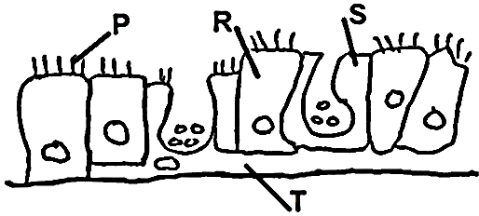

Which part represents the cell which produce mucus which moisten air and protect the epithelium?

A. R B. T C. S D. P

11. The swimming action in fish is brought about mainly by the contraction of;

A. cardiac muscles B. involuntary muscles

C. skeletal muscles D. myotome muscles

12. Which one of the following is not a permanent method of family planning?

A. vasectomy

B. tubal ligation

C. womb removal

D. intra uterine contraceptive device (IUCD)

13. Mosquitoes and other insects can be a big problem in the district. There should be an officer to deal with insects. The officer should have studied a branch of Biology called?

A. entomology B. insectology

C. pathology D. parasitology

14. Which one of the following pair of characteristics in living things is shown by a baby who touched a hot spoon and immediately withdrew its hand?

A. growth, movement B. sensitivity and locomotion

C. sensitivity and movement D. respiration and excretion

15. The arrangement of thorax parts from the head side of an insect is:

A. prothorax, metathorax, meso thorax.

B. meso thorax, meta thorax, and pro thorax

C. meta thorax, meso thorax, pro thorax

D. pro thorax, meso thorax, meta thorax

16. Which one of the following statements is true about digestion in man?

A. digestion of sucrose starts in the stomach

B. digestion of sucrose starts in the ileum

C. sucrose is digested to glucose in the ileum

D. sucrose is converted to glucose and galactose

17. The blood pressure is greatest in the;

A. pulmonary artery B. aorta

C. inferior venacava D. jugular vein

18. Simple aquatic plants containing chlorophyll and usually with bodies not differentiated into root, stem and leaves are:

A. fungi B. liver worts

C. mosses D. algae

19. A population in equilibrium could be the characteristic of a natural community in which;

A. pioneer organisms are increasing rapidly

B. immigration is occurring rapidly

C. the pyramid of energy has reversed

D. succession has reached a climax

20. Which one of the following in an excretory function of the mammalian liver?

A. conversion of glycogen to glucose

B. conversion of fats to fatty acids and glycerol

C. conversion of amino acids to urea.

D. production of vitamin B.

21. The sound vibrations are converted into nervous impulses in the part of the ear known as:

A. Ear drum B. semi-circular canal

C. Cochlea D. outer ear

22. The type of muscles found in the gut, excretory systems and blood vessels of a mammalian body is described as:

A. skeletal B. involuntary

C. striped D. voluntary

23. Senior four candidates observed a figure which had identical twins with their heads joined. Through their research they found out that these are called siamese twins. Select he statement that is not true about siamese twins. They ………

A. develop from one egg and one sperm

B. have different genotypes

C. share some parts of the body

D. belong to the same sex

24. The figure below shows a chick developing in an egg.

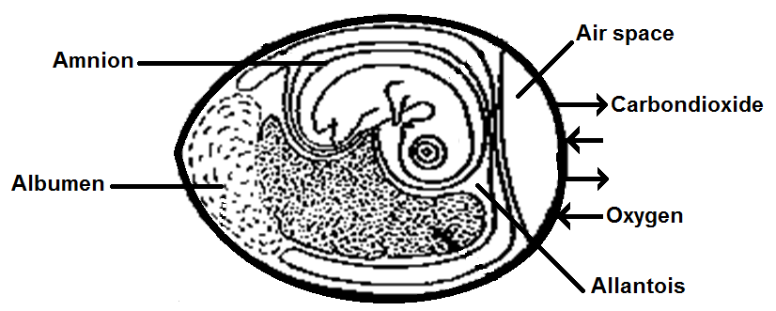

Where are the nitrogenous wastes produced by the chick stored?

A. Amnion B. Allantois

C. Albumen D. Air space

25. Which of the following belongs to a different class?

A. Tilapia B. shark

C. whale D. Nile perch

26. Where in a cell is mutation likely to occur?

A. nucleus B. mitochondrion

C. chromosome D. nucleorus

27. Fainting occurs in people because of …………………

A. excessive loss of blood

B. excitement

C. not enough blood getting to the brain

D. not having enough blood in the body.

28. Select the best practice in utilizing natural resources for development.

A. preservation B. protection

C. conservation D. exploitation

29. The following organs are found in a mammal.

i) pancreas

ii) stomach

iii) duodenum

iv) ileum

Which of them produces both enzymes and hormones?

A. i) only B. ii) and iii)

C. i) and iv) D. i) and iii)

30. The term ‘protandrous’ refers to …………………

A. bisexual plant

B. stamens maturing before carpels

C. male and female flowers growing on different plants.

D. carpels maturing before stamen.

**SECTION B: (40 marks)**

31. A candidate seated in a dark room is asked to cover one of this eyes. A dim light bulb positioned at varying distances from the person is switched on at one minute intervals for ten (10) minutes. During this period, the diameter of the pupil of the eye was measured. The results were shown in the figure below. Study it carefully and then answer the questions that follow.

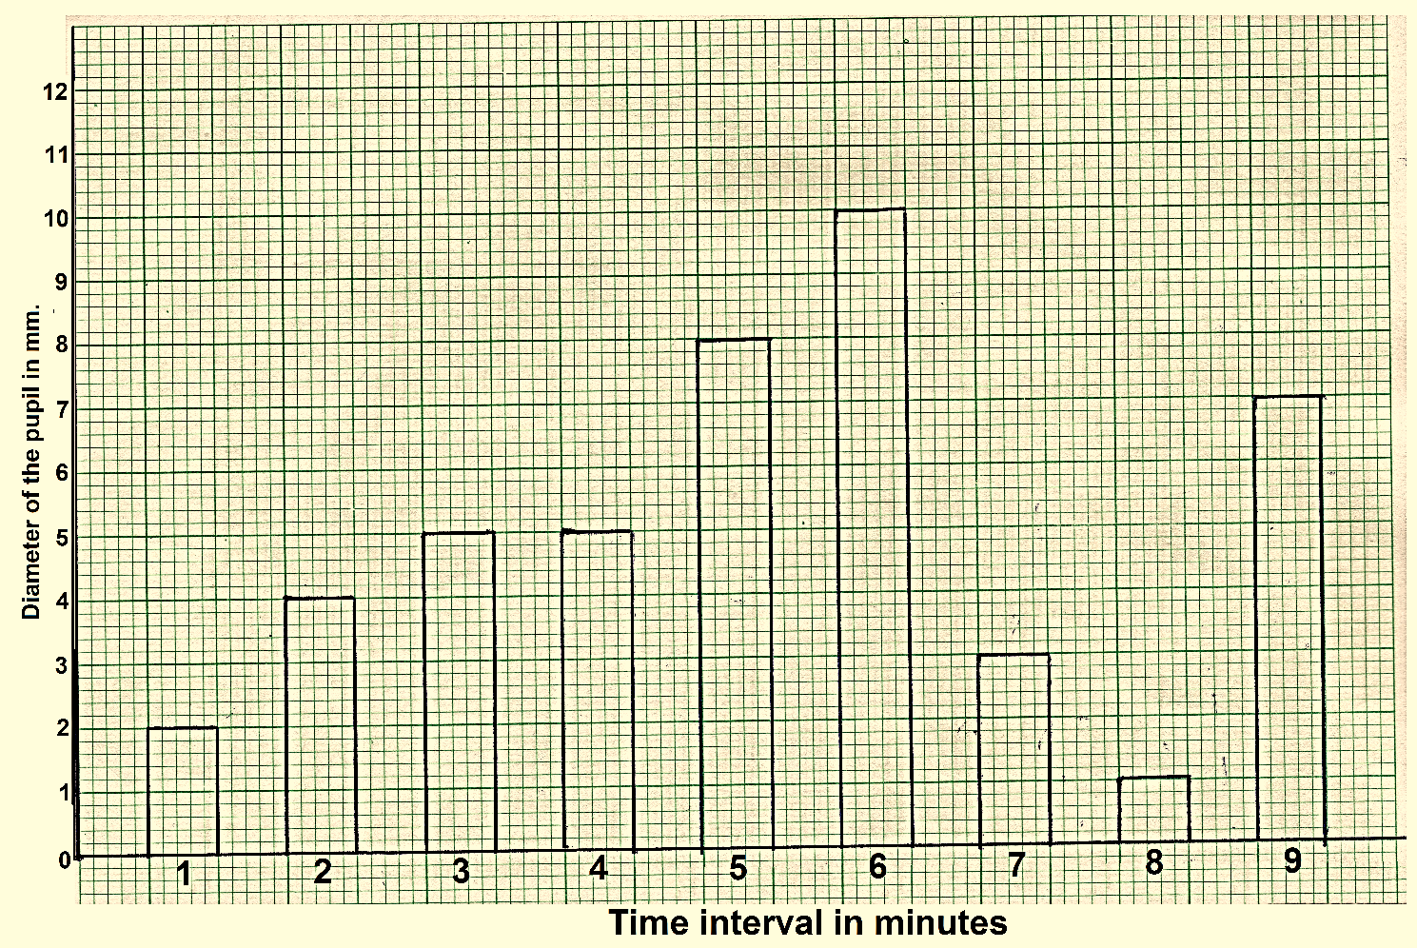

a) Which structure in the eye regulates the size of the pupil? (1 mark)

**…………………………………………………………………………………………………**

b) i) At which time intervals did the diameter of the pupil remain the same? (½ mark)

**…………………………………………………………………………………………………**

ii) Explain why the diameter remained the same. (1½ marks)

**…………………………………………………………………………………………………**

**…………………………………………………………………………………………………**

**…………………………………………………………………………………………………**

c) i) At what time interval was the light bulb furthest away from the person? (1 mark)

**…………………………………………………………………………………………………**

ii) Explain your answer in c (i) above. (3 marks)

**…………………………………………………………………………………………………**

**…………………………………………………………………………………………………**

**…………………………………………………………………………………………………**

**…………………………………………………………………………………………………**

d) Explain how and why the pupil adjusted from the diameter of 1mm to a diameter of 7mm. (5 marks)

**…………………………………………………………………………………………………**

**…………………………………………………………………………………………………**

**…………………………………………………………………………………………………**

**…………………………………………………………………………………………………**

**…………………………………………………………………………………………………**

**…………………………………………………………………………………………………**

e) i) Describe how a faraway object in contact with the bulb at a given time interval was accommodated by the eye. (3 marks)

**…………………………………………………………………………………………………**

**…………………………………………………………………………………………………**

**…………………………………………………………………………………………………**

**…………………………………………………………………………………………………**

**…………………………………………………………………………………………………**

**…………………………………………………………………………………………………**

**…………………………………………………………………………………………………**

**…………………………………………………………………………………………………**

ii) Why is the pupil considered to have a protective function to the mammalian eye? (2 marks)

**…………………………………………………………………………………………………**

**…………………………………………………………………………………………………**

**…………………………………………………………………………………………………**

**…………………………………………………………………………………………………**

f) Suggest any three adaptations of the mammalian eye to its function of accommodation. (3 marks)

**i) ………………………………………………………………………………….**

**…………………………………………………………………………………………………**

**ii) …………………………………………………………………………………**

**…………………………………………………………………………………………………**

**iii) …………………………………………………………………………………**

**…………………………………………………………………………………………………**

32. The table below shows the characteristics of some animals. Study it carefully and answer the questions that follow.

|  |  |
| --- | --- |
| **Animal** | **Characteristics** |
| X | External fertilization, use lungs, skin and mouth lining for breathing. |
| Y | Internal fertilization, eggs laid on land, dry scally skin, ectothermic, distinct legs, and use lungs only for breathing. |
| Z | External fertilization, eggs laid in water, uses gills for gaseous exchange, paired fins for locomotion, ectothermic. |

a) With at least two examples in each case, state the class to which each of the following animals belong. (4½ marks)

i) X Class: **……………………………………………………** (½ mark)

Example: **………………………………………………..** (1 mark)

ii) Y Class: **……………………………………………………** (½ mark)

Example: **………………………………………………..** (1 mark)

iii) Z Class: **……………………………………………………** (½ mark)

Example: **………………………………………………..** (1 mark)

b) Give the major nitrogenous excretory product released by the animals in relation to their habitats when still young. (1½ marks)

i) X. **…………………………………………………………………….**

ii) Y. **…………………………………………………………………….**

iii) Z. **…………………………………………………………………….**

c) Suggest one way how the embryo of animal Y is advantageous to animal X and Z. (1 mark)

**…………………………………………………………………………………………………**

**…………………………………………………………………………………………………**

d) How is animal Z adapted to live in its habitat? (3 marks)

i) **……………………………………………………………………………….....**

**…………………………………………………………………………………………………**

ii) **……………………………………………………………………………….....**

**…………………………………………………………………………………………………**

iii) **……………………………………………………………………………….....**

**…………………………………………………………………………………………………**

33. Three set up experiments where arranged as shown in the figures below. Study them and answer the questions that follow.

Set up 1. Placed in sunlight at day light temperature.

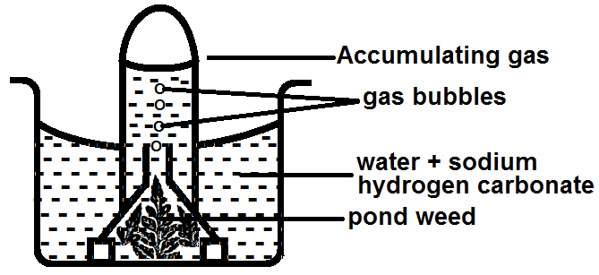

Set up 2. Placed in sunlight with ice cubes in water.

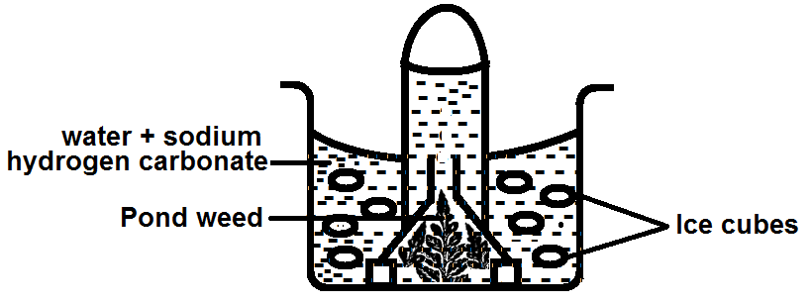

Set up 3. Placed in sunlight with hot water at 500C.

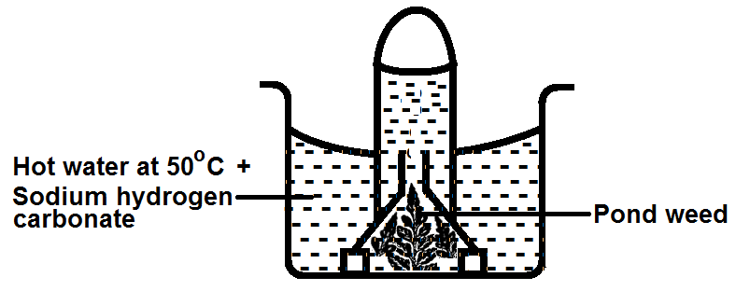

a) i) What aspect of the process is being investigated in the experiments set up above. (1 mark)

**…………………………………………………………………………………………………**

**…………………………………………………………………………………………………**

ii) Give the observations you would expect in the three set ups when left exposed to sunlight for 4 hours. (3 marks)

Observation in set up 1.

**…………………………………………………………………………………………………**

**…………………………………………………………………………………………………**

Observation in set up 2.

**…………………………………………………………………………………………………**

**…………………………………………………………………………………………………**

Observation in set up 3.

**…………………………………………………………………………………………………**

**…………………………………………………………………………………………………**

b) Explain the observations described in a (ii) above. (3 marks)

Set up 1.

**…………………………………………………………………………………………………**

**…………………………………………………………………………………………………**

Set up 2.

**…………………………………………………………………………………………………**

**…………………………………………………………………………………………………**

Set up 3.

**…………………………………………………………………………………………………**

**…………………………………………………………………………………………………**

c) How can you verify the identity of the gas that accumulates in the;

i) Test tube of set up 1? (2 marks)

**…………………………………………………………………………………………………**

**…………………………………………………………………………………………………**

**…………………………………………………………………………………………………**

**…………………………………………………………………………………………………**

ii) Suggest any other two environmental factors that affect the rate of the process investigated above. (1 mark)

**…………………………………………………………………………………………………**

**…………………………………………………………………………………………………**

**SECTION C: (30 marks)**

**(Attempt only two (2) questions from this section)**

34. a) Describe the process of swallowing of food. (6 marks)

b) State the role of the different digestive juices secreted along the human gut. (9 marks)

35. a) What is meant by excretion? (2 marks)

b) Explain why the liver has such a large volume of blood flowing through it? (2 marks)

c) How is the mammalian liver important in the process of Homeostasis?

(11 marks)

36. a) What is meant by reproduction? (2 marks)

b) Describe how the spirogyra reproduces.

i) Asexually. (3 marks)

ii) Sexually. (8 marks)

c) What are the advantages of sexual reproduction over asexual reproduction? (Any two) (2 marks)

37. a) Differentiate between primary growth and secondary growth. (1 mark)

b) Compare growth in plants and animals. (6 marks)

c) Describe an experiment to show that oxygen is necessary for germination. (8 marks)

**END**